167.64

Sample Output 1

5 6

Sample Input 1

Note: All of the values should be displayed using two decimal places.

In one line print the height in centimeters.

Output Format

Second line, read the number of inches.

First line,read the number of feet.

Input Format

One inch is 2.54 centimeters.

One foot is 12 inches.

Hint:

Once these values are read, your program should compute and display the equivalent number of centimeters.

metric system. Write a program that reads a number of feet from the user, followed by a number of inches.

**Q1)** Many people think about their height in feet and inches, even in some countries that primarily use the

**Week-02-01-Practice Session-Coding**

**Week 2**

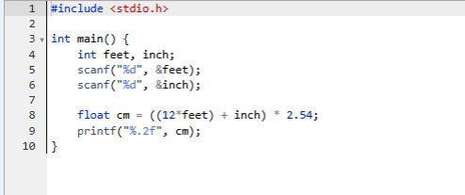

Output:

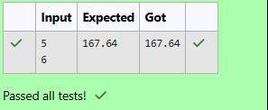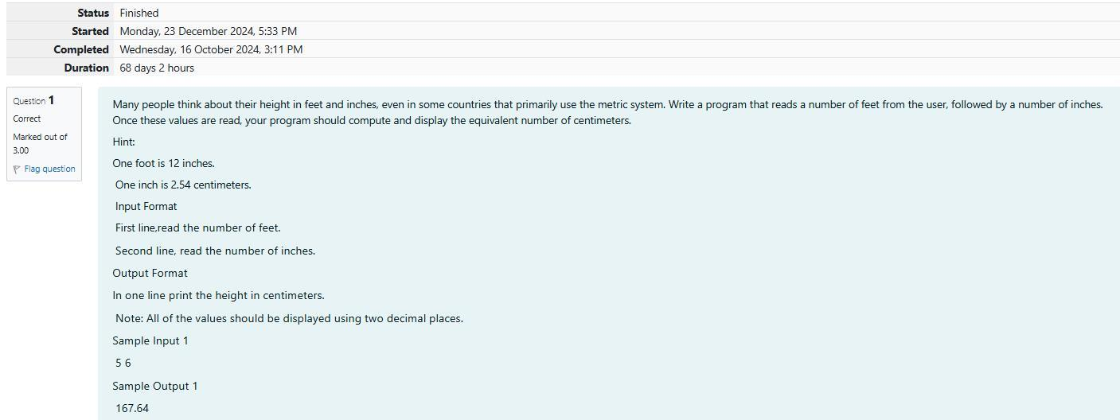

**Ouput:**

106 94 600 16 4

Sample Output

Input 1 100 6

Sample

Fifth line, print the remainder when a is divided by b

Fourth line, print the quotient when a is divided by b

Third line, print the product of a and b

Second line, print the difference when b is subtracted from a

First line, print the sum of a and b

Output Format

Second line, read the second number.

First line, read the first number.

Input Format

quotient when a is divided by b • The remainder when a is divided by b

display: • The sum of a and b • The difference when b is subtracted from a • The product of a and b • The

**Q2)** Create a program that reads two integers, a and b, from the user. Your program should compute and

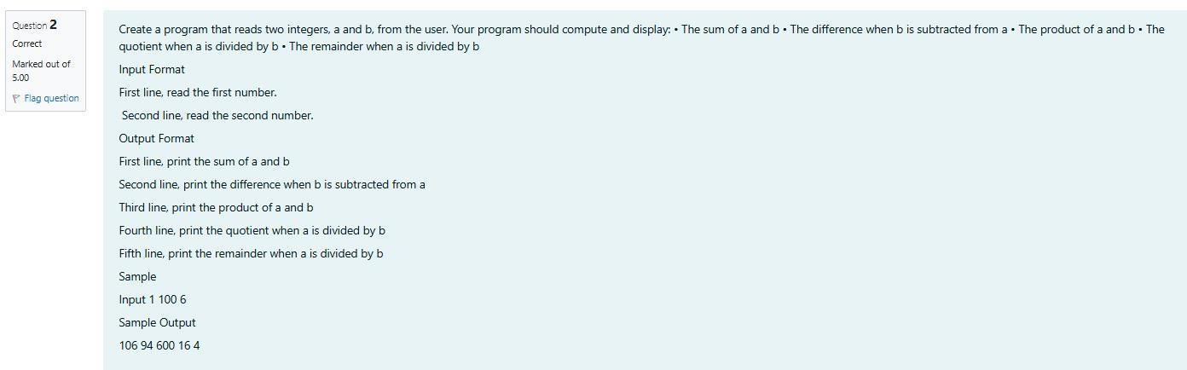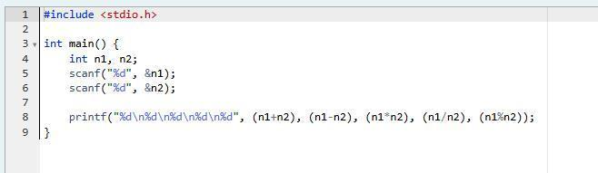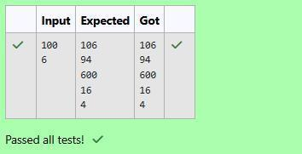

**Output:**

Total: 13.96

Discount: 20.94

Regular price: 34.90

Sample Output 1

10

Sample Input 1

Note: All of the values should be displayed using two decimal places.

Third line, print Total: total

Second line, print Discount: discount

First line, print Regular price: price

Output Format

Read the number of day old loaves.

Input Format

values should be displayed using two decimal places.

tal price. Each of these amounts should be displayed on its own line with an appropriate label. All of the

your program should display the regular price for the bread, the discount because it is a day old, and the to-

gram that begins by reading the number of loaves of day old bread being purchased from the user. Then

**Q3)** A bakery sells loaves of bread for $3.49 each. Day old bread is discounted by 60 percent. Write a pro-

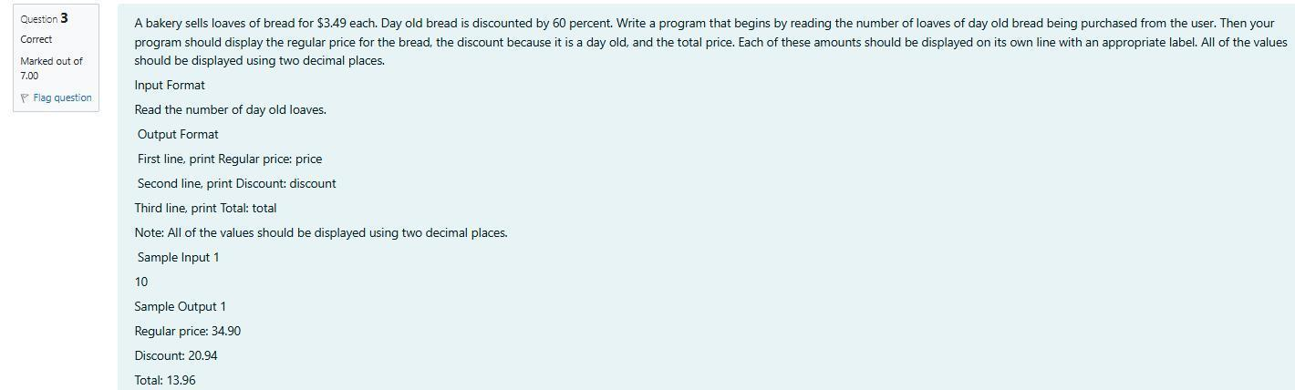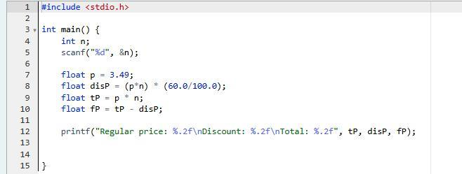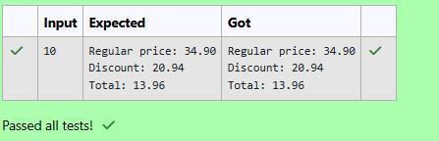

NO

SAMPLE OUTPUT 2

100 90

SAMPLE INPUT 2

YES

SAMPLE OUTPUT 1

100 110

SAMPLE INPUT 1

1<=X,Y<=1000000

1<=N<=1000000

CONSTRAINTS

________________________________________

quotes).

Print if he can be friend with Goki. 'YES' (without quotes) if he can be friends with Goki else 'NO' (without

OUTPUT

. ________________________________________

contains one integer Y - denoting the skill of the person

First line contains a single integer X - denoting the minimum skill required to be Goki's friend. Next line

INPUT

________________________________________

wants atleast X skills in his friends. Help Goki find his friends.

he can be friends with, so he decides to choose among them according to their skills set Yi(1<=i<=n). He

Q1) Goki recently had a breakup, so he wants to have some more friends in his life. Goki has N people who

**Week-02-02-Practice Session-Coding**

**Output:**

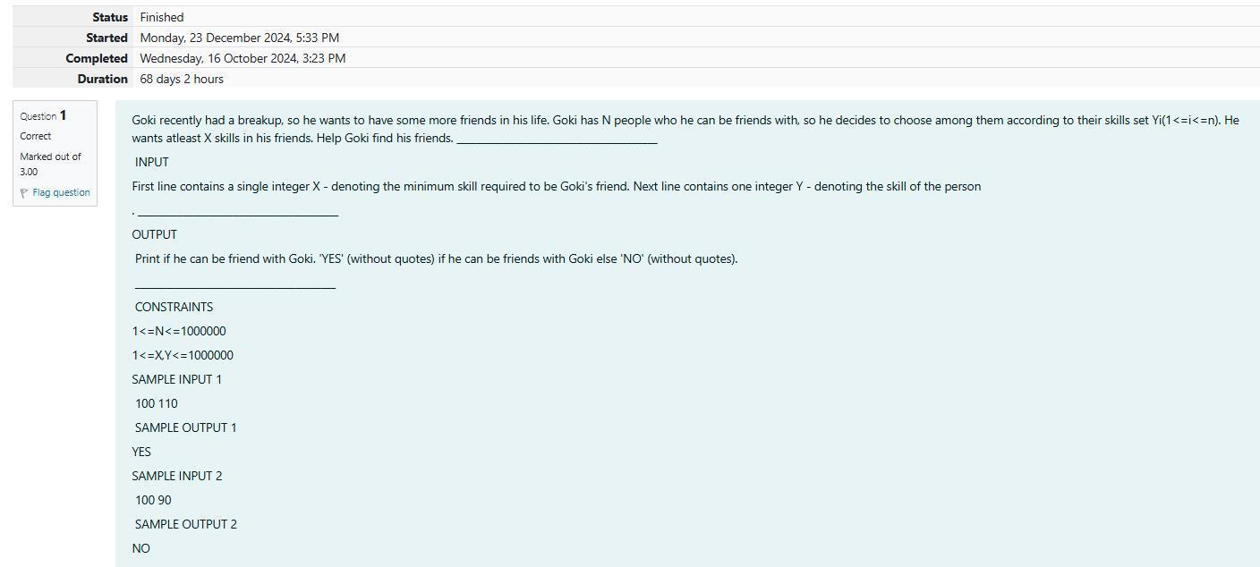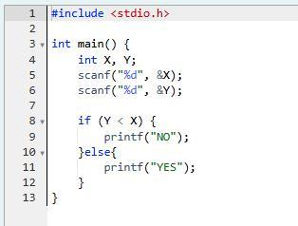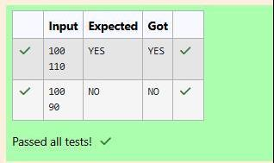

**Output:**

bers, 1 handshake takes place.

Explanation Case 1: The lonely board member shakes no hands, hence 0. Case 2: There are 2 board mem-

1

SAMPLE OUTPUT 2

2

SAMPLE INPUT 2

0

SAMPLE OUTPUT

1

SAMPLE INPUT 1

0 < N < 106

Constraints

Print the number of handshakes.

Output Format

Read an integer N,the total number of people attended that meeting.

Input Format

handshakes happened in that meeting? Say no to shakehands. Regularly wash your hands. Stay Safe.

got infected! Given the fact that any two persons shake hand exactly once, Can you tell the total count of

ing hands with everyone else in the room as a gesture of respect and after meeting unfortunately everyone

who attended that meeting had COVID-19 and no one in the room knew about it! So everyone started shak-

Q2) Before the outbreak of corona virus to the world, a meeting happened in a room in Wuhan. A person

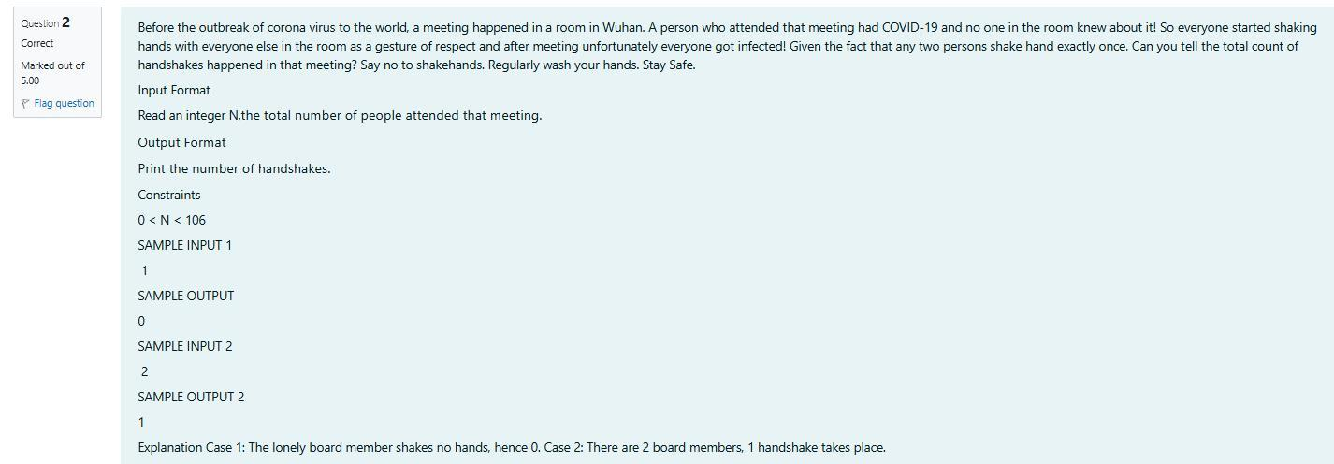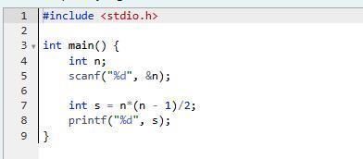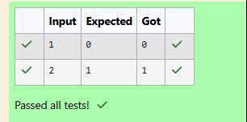

**Output:**

Explanation Out of given numbers, 8 is maximum.

8

SAMPLE OUTPUT

8 6 1

SAMPLE INPUT

Maximum integer value

Output:

Three space separated integers.

Input:

in input. Output the maximum of these numbers.

tell him which is the maximum point value, so that Raghav can select best technique. 3 numbers are given

could be most beneficial for dismissing Jatin. He has given points to each of the 3 techniques. You need to

opponent - Jatin, who is very good batsman. Raghav has figured out 3 types of bowling techniques, that

want to lose it. So he has done a lot of planning to make sure his teams wins. He is worried about only one

school now. After that he will pass out from school. So, this match is very important to him. He does not

tain of his team. He always wanted to win all cricket matches. But only one last Games period is left in

Q3) In our school days, all of us have enjoyed the Games period. Raghav loves to play cricket and is Cap-

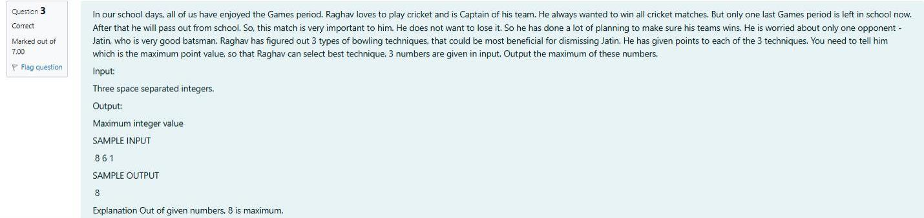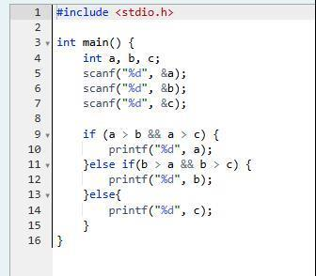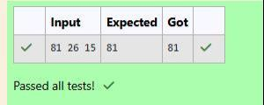

}

return 0;

printf("_i_am_also_a_valid_identifier = %d\n", _i_am_also_a_valid_identifier);

printf("second_number = %d\n", second_number);

printf("firstNumber = %d\n", firstNumber);

printf("age = %d\n", age);

digits are allowed as first character of the identifier/variable name.

// An identifier/variable name must be start with an alphabet or underscore (_) only, no other special characters,

**int** _i_am_also_a_valid_identifier = 4; // _i_am_also_a_valid_identifier is an integer variable

space.

// Any space cannot be used between two words of an identifier/variable; User can use underscore (_) instead of

**int** second_number = 3; // second_number is an integer variable

iable.

// If there are two or more words in an identifier/variable - User can also use "camel case" style to declare a var-

**int** firstNumber = 2; // firstNumber is an integer variable

**int** age = 2; // age is an integer variable

{

**int**  main()

#include <**stdio.h**>

For example, consider the program given below:

Q1) Read the code given below to learn naming conventions in identifiers.

**Coding-Variables and Keywords**

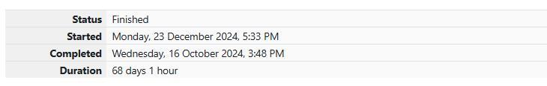

**Output:**

Fill in the missing code in the below program to print the values of the given variables.

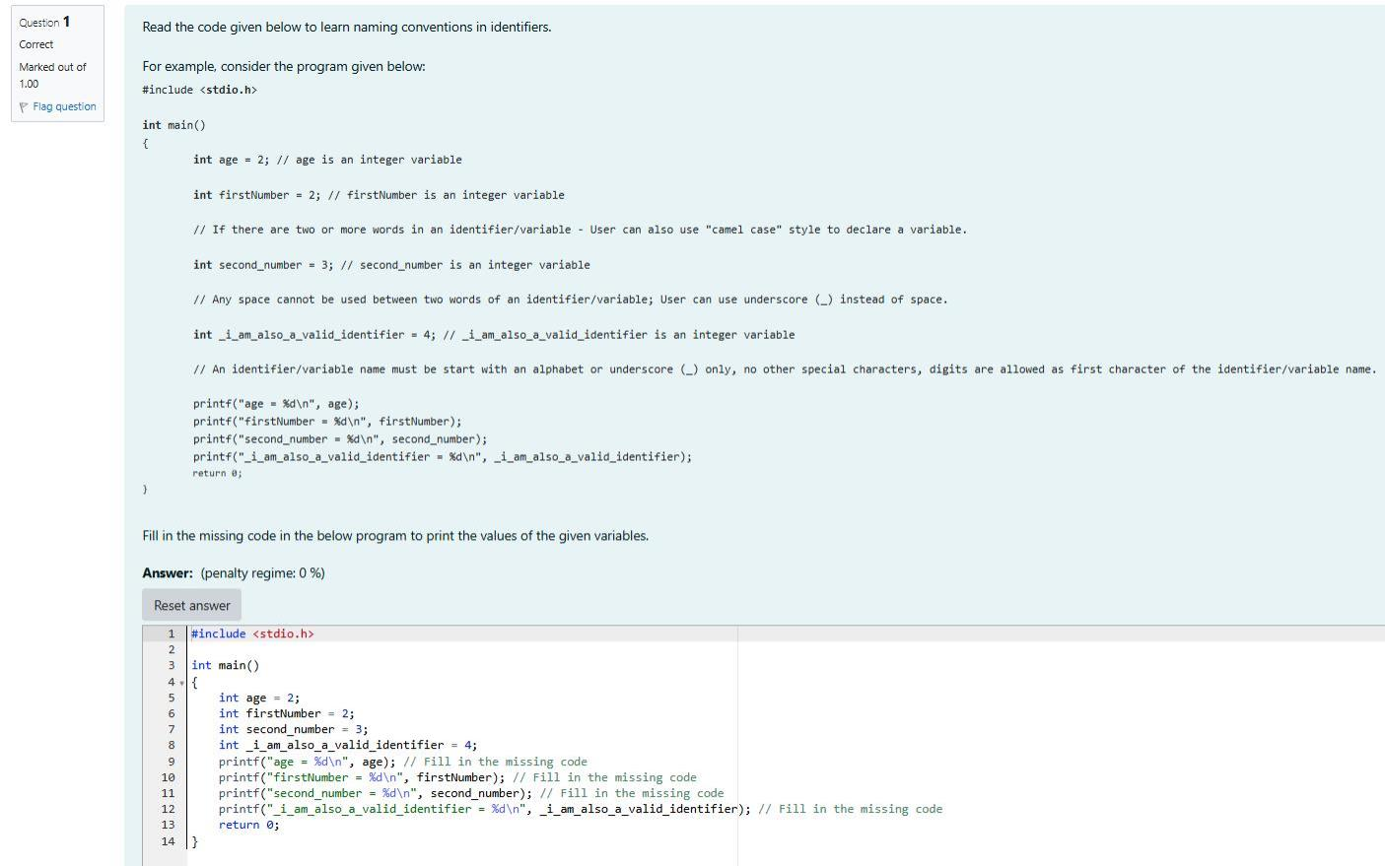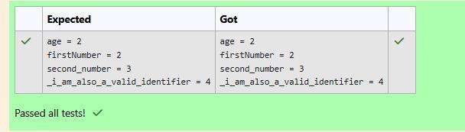

**Output:**

Q1) Identify and correct the error in the code given below.

**Coding-Syntax of main() function**

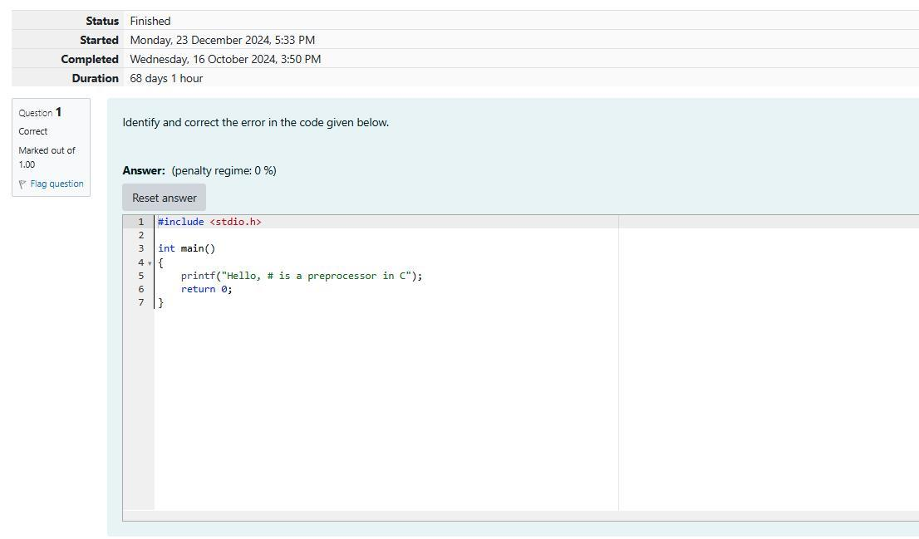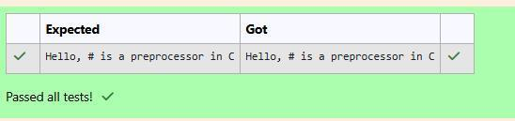

}

return 0;

printf("Impossible is nothing!");

{

int main()

#include <stdio.h>

provided.

Read the code given below to familiarize yourself with the syntax of main() function. Retype in the space

not the main function which is called by the OS.

The name of the main() function should always be in lowercase, i.e., if a function is written as Main(), it is

If the programmer does not specify any return type, the return type is by default considered as int.

**}**

return 0;// 0 value indicates that the execution is successful

printf("Sample main() function with int as return type!");

**{**

**int main()**

**#include <stdio.h>**

In **C**, **main()** can be written in such a way that it returns a an int.

program is successful.

When the **OS** executes a program, the program usually returns an integer value 0 if the execution of that

While executing a **C** program, the **Operating System (OS)** only calls the main() function in that program.

(a programmer) writes the code for the main() function.

the name given to a set of one or more executable statements. main() is a **user defined function**, i.e., a user

We shall learn more about functions in the later sections. For now, we can safely assume that **function**  is

Q2) In **C** programming language, execution of the code starts with a function called main.

**Output:**

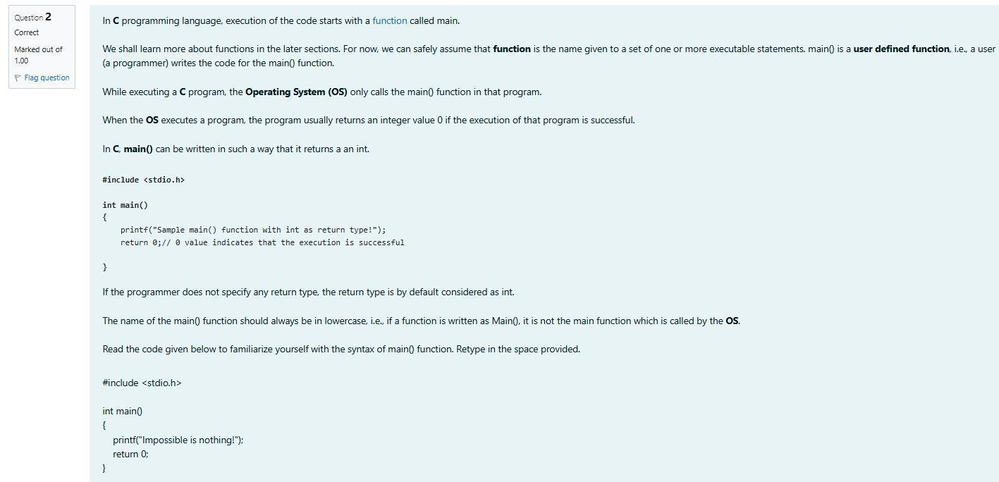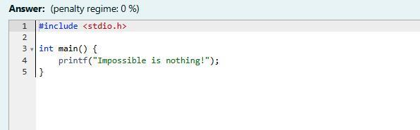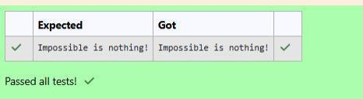

Q3) Identify and correct the error in the code given below.

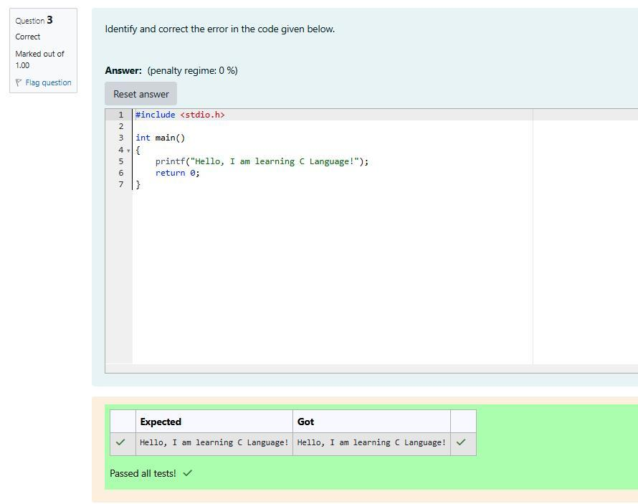

Now, correct the spelling of the main function and submit the program once again.

This results in many errors because the main function is not defined correctly.

Q4) Click on Check without correcting the code.

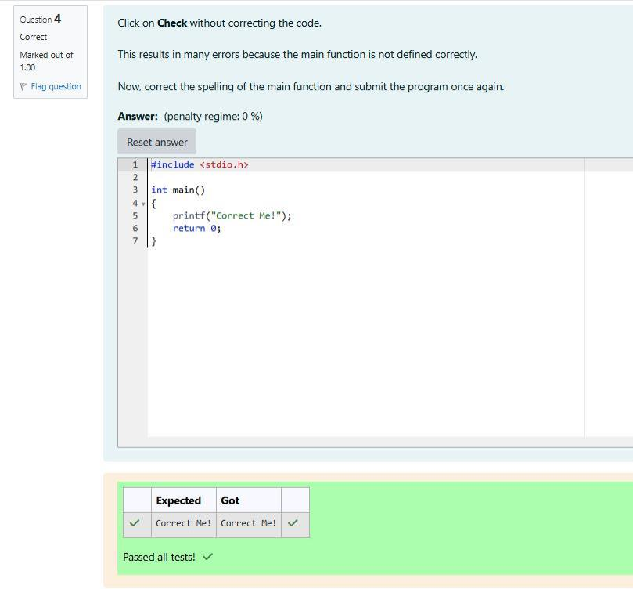

Q5) Identify and correct the error in the code given below.

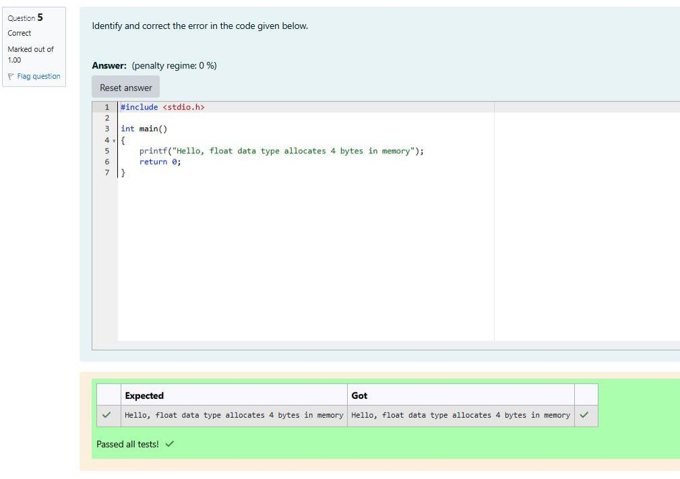

**Output:**

}

return 0;

printf("asciiValueOfA value = %d\n", asciiValueOfA);

int asciiValueOfA = 'A';

printf("asciiValueOfOne value = %d\n", asciiValueOfOne);

int asciiValueOfOne = '1';

printf("hexTen value = %d\n", hexTen);

int hexTen = 0xA;

printf("octalEight value = %d\n", octalEight);

int octalEight = 010;

printf("binaryThree value = %d\n", binaryThree);

int binaryThree = 0b11;

{

int main()

#include <stdio.h>

Read the code given below and retype in the space provided.

and character literals.

Q1) In the program given below, we shall learn how to assign values to int data type from binary, octal, hex

**int Data Type**

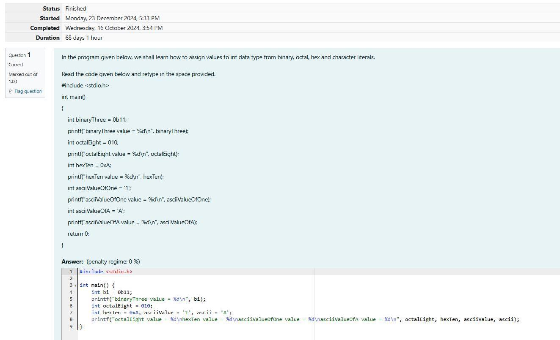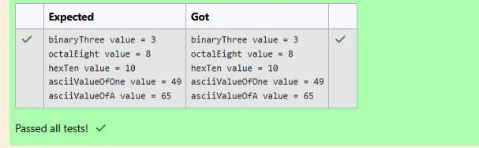

Q2) In the program given below, fill in the missing code to add two integer numbers.

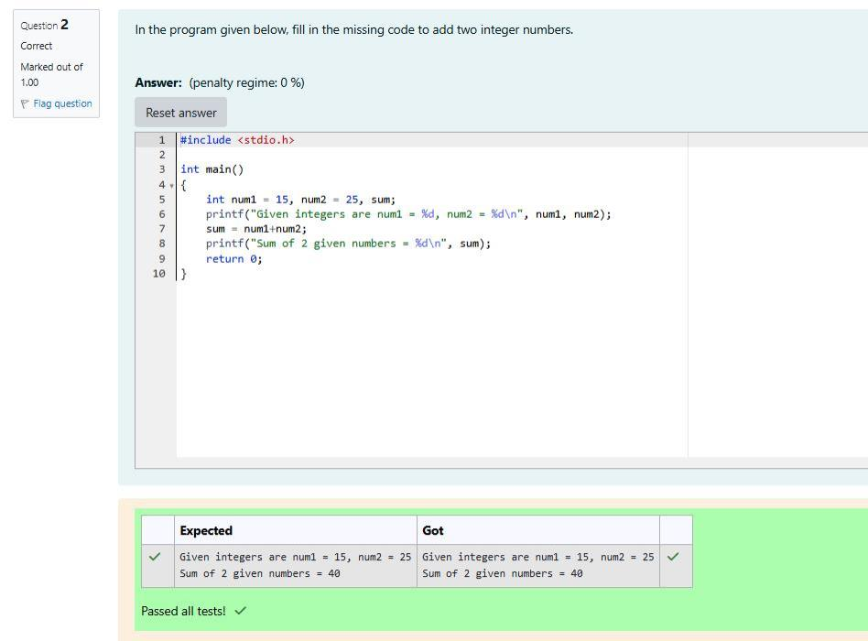

In the program given below, fill in the missing format characters to print signed and unsigned values.

The final value in **num** = 4294967295 (in a 32-bit processing system)

The value stored in **num** = unsigned int **maximum_value** + **1** - **num**;

unsigned int **num** = -1;

positive number as shown below:

1;) the compiler does not flag it as an **error**. Instead, it will automatically convert the negative number to a

Whenever an attempt is made to assign a negative number to an **unsigned int** ( For eg: unsigned int num = -

Q3) To print unsigned values on the console, use %u format character instead of %d in the **printf()**  function.

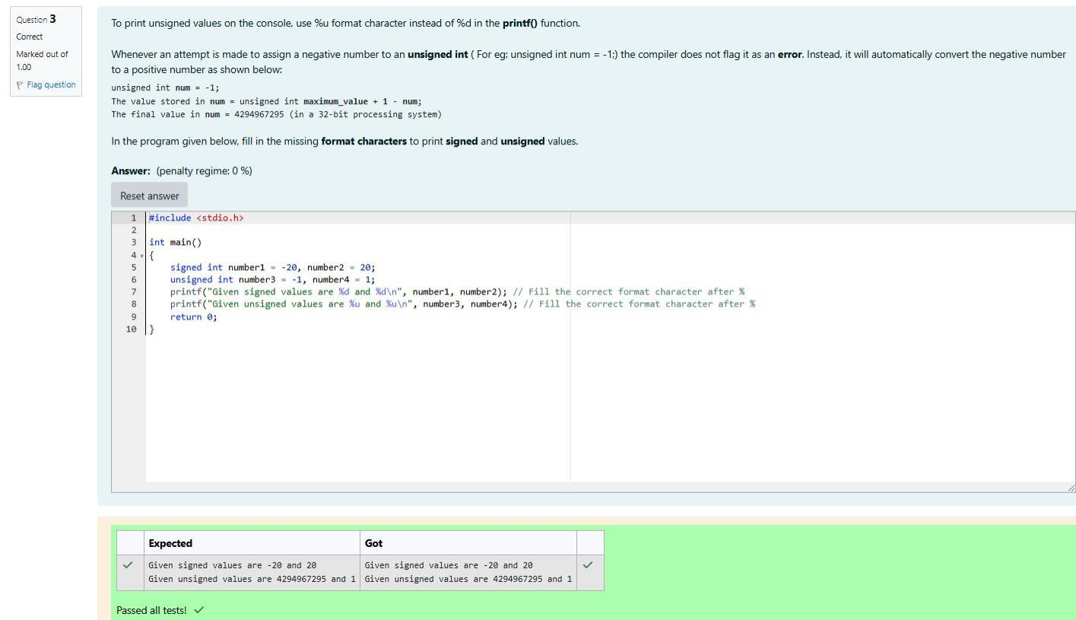

used.]

Q4) Identify the error and correct the code. [**Hint**: Verify if all variables are declared before they are first

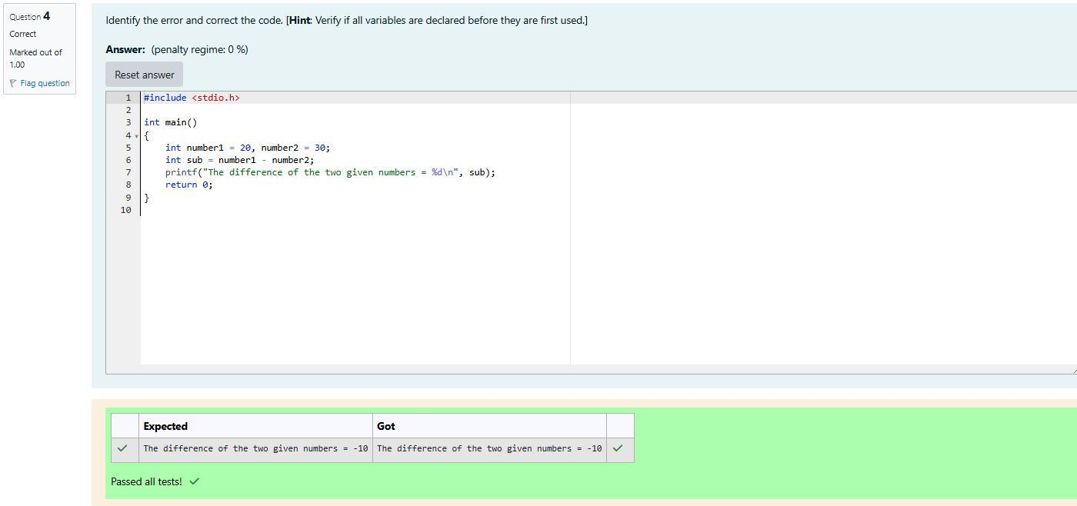

The result after dividing in exponential format = 2.355599e+01

The result after dividing in float format = 23.555992

Given float values are num1 = 5.340000, num2 = 125.789001

Expected Output:

Q1)Identify and correct the errors in the code given below:

**float Data Type**

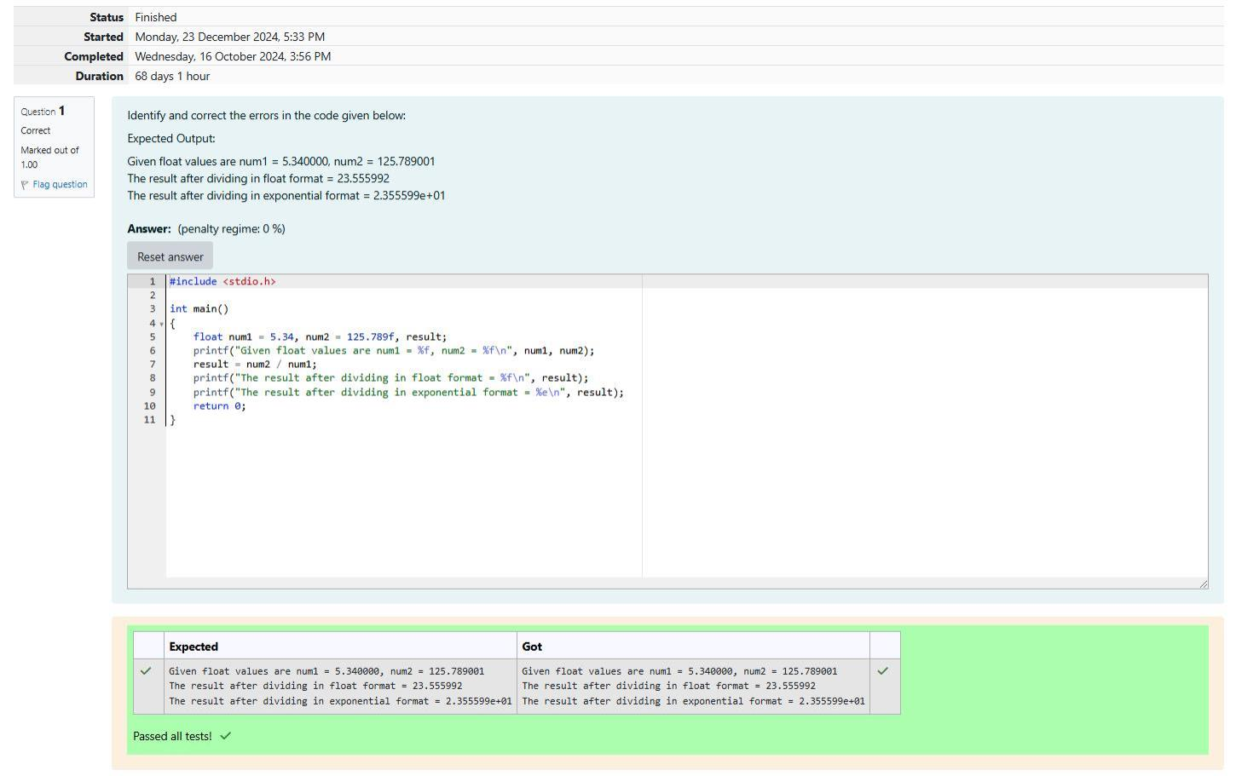

Q2) Identify and correct the errors in the code given below:

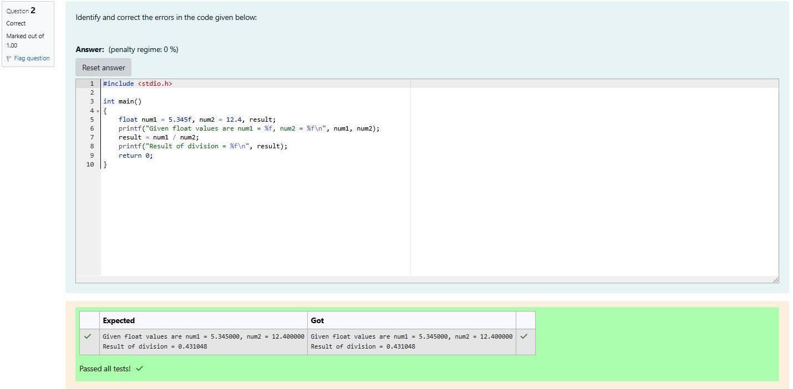

20 

1000 

50

140

**Input Result**

For example:

1000

140

Sample Output:

20

50

Sample Input:

to the quantity of carpet required.

Output Consists of two integers. The first integer corresponds to the length. The second integer corresponds

Output Format:

corresponds to the breadth of the ground.

Input consists of 2 integers. The first integer corresponds to the length of the ground and the second integer

Input format:

to find the exact length of the rope and the exact quantity of carpet that is required?

quantity of carpet that is needed. They requested your help. Can you please help them by writing a program

also wanted to cover the entire ground with a carpet during rainy season. They wanted to buy only the exact

a thick rope around the ground. They wanted to buy only the exact length of the rope that is needed. They

protect the stadium by building a fence. In order to help the workers to build a fence, they planned to place

zone. In order to protect the land from using as an unauthorized parking zone, the corporation wanted to

build a Cricket stadium in the area for school and college students, But the area was used as a car parking

Q1)There was a large ground in center of the city which is rectangular in shape. The Corporation decides to

**Cricket Stadium**



**Output:**

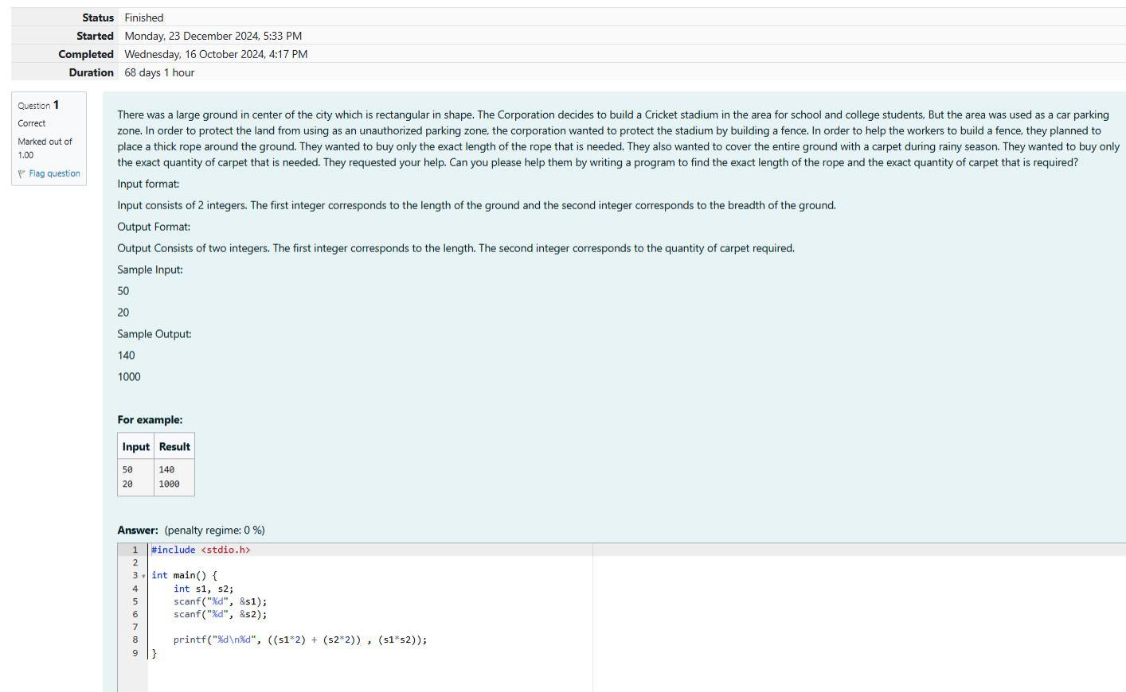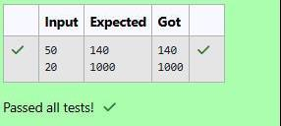

8 

4 

60

7

**Input Result**

For example:

4

7

SAMPLE OUTPUT:

8

60

SAMPLE INPUT:

and the second integer corresponds to the students who are left out.

The output consists of two integers. The first integer corresponds to the number of students in each team

OUTPUT FORMAT:

ond integer corresponds to the number of teams.

Input consists of 2 integers. The first integer corresponds to the number of students in the class and the sec-

INPUT FORMAT:

ting task. Can you please help him out?

1 student will assist the PET. With this idea in mind, the PET wants your help to automate this team split-

be divided into 7 equal sized teams, 7 students will be there in each team and 1 student will be left out. That

sist him in conducting the team games. For instance, if there are 50 students in a class and if the class has to

there may be some students who are left out from the teams and he wanted to use the left out students to as-

games. The teacher wants to split the students in higher secondary into equal sized teams. In some cases,

Q1)Training for sports day has begun and the physical education teacher has decided to conduct some team

**Sports Day Celebration**



Output:

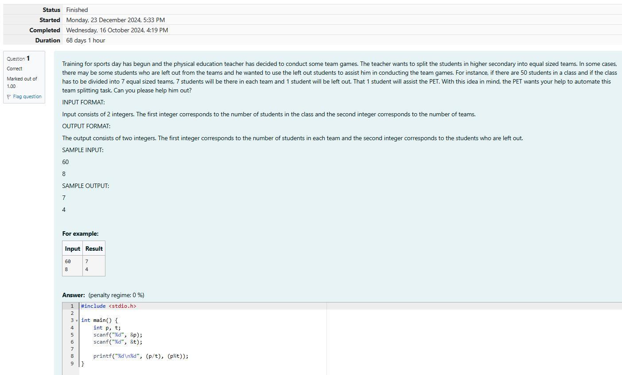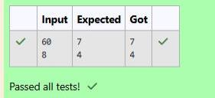

1 

2

900 

1000

**Input Result**

For example:

900

SAMPLE OUTPUT:

1

2

1000

SAMPLE INPUT:

The output consists of a single integer which corresponds to the profit obtained by the newspaper agency.

OUTPUT FORMAT:

cost the agency spends per copy.

Input consists of 3 integers: w, x, and y. w is the number of copies sold, x is the cost per copy and y is the

INPUT FORMAT:

Can you please help them out by writing a program to compute the profit if w, x, and y are given?

of Rs.100 per Sunday. The newspaper agency wants to calculate the profit which it obtains only on Sundays.

cost to the agency of each newspaper is Rs.y. The agency pays a fixed cost for storage, delivery and so on

Q1) Each Sunday, a newspaper agency sells w copies of a special edition newspaper for Rs.x per copy. The

**The Newspaper Agency**

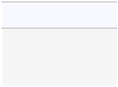

**Output:**

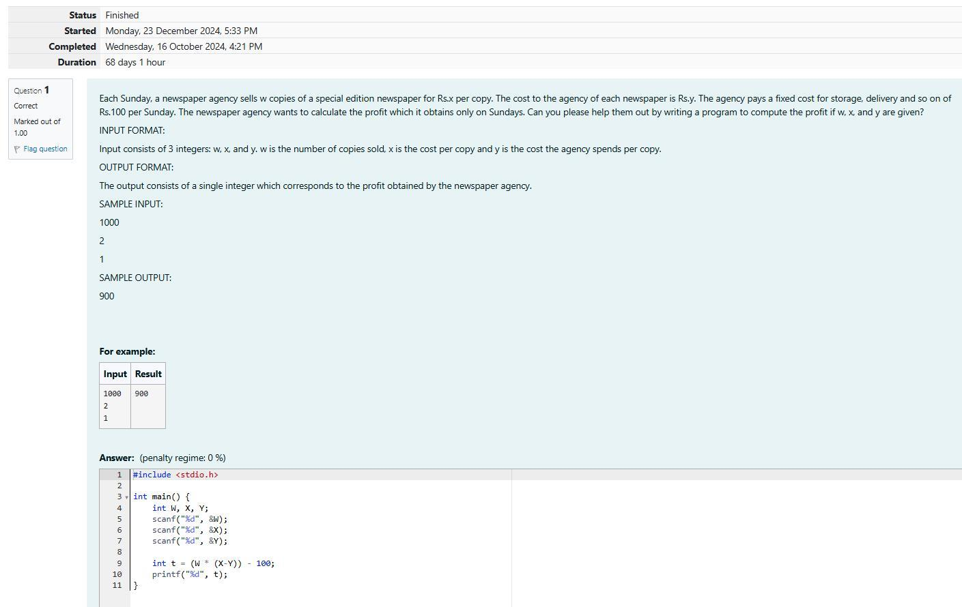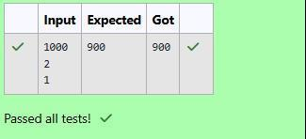

87  15 

**Input Result**

For example:

15

SAMPLE OUTPUT:

87

SAMPLE INPUT:

Output consists of an integer corresponding to the sum of its digits.

Output Format:

Input consists of an integer corresponding to the 2-digit number.

Input Format:

the others. Lucy was already confused, so please help her in finding the route to her home....

of digits of the tree and that numbered way will lead her to the tree next to the wardrobe where she can find

first tree with two digits number will help her find the way and the way to go back to her home is the sum

find the route back as it was already dark. He told her to see the trees while returning back and said that the

family and so she bid good bye to Mr.Tumnus and while leaving Mr.Tumnus told that it is quite difficult to

came friends and he offered a cup of coffee to Lucy in his small hut.It was time for Lucy to return to her

found Mr.Tumnus the two legged stag ,and she followed it, down a narrow path .She and Mr.Tumnus be-

fantasy world of magic with mythical beasts and talking animals.While exploring the land of narnia Lucy

Q1) Four kids Peter, Susan, Edmond and Lucy travel through a wardrobe to the land of Narnia. Narnia is a

**The Chronicles of Narnia**

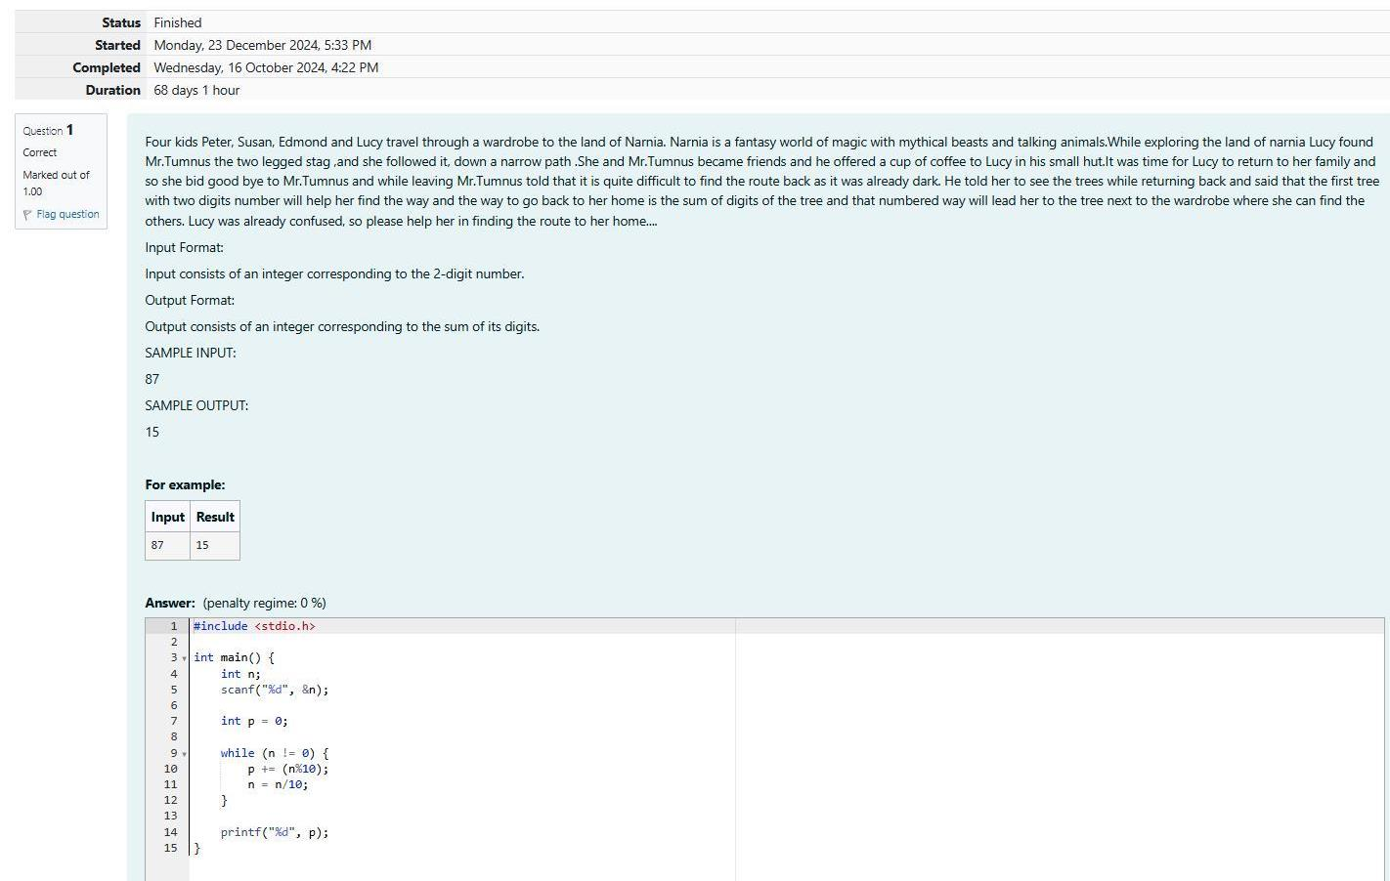

**Output:**

